Last Mile Connectivity

**Easy, Green and Cheap**

High Level Solution Approach

Last Mile Connectivity



|  |  |  |  |  |
| --- | --- | --- | --- | --- |
| **Revision History** | |  |  |  |
| Version | Date |  | Author/Contributor | Comments |
| 0.1 | Mar 19, 2017 |  | Prateek Varshney | Initial draft |
|  |  |  |  |  |
|  |  |  |  |  |



Page 2

Last Mile Connectivity

**Contents**

|  |  |  |  |
| --- | --- | --- | --- |
| 1. | Introduction .................................................................................................................................... | | 4 |
| 1.1. | | Executive Summary ................................................................................................................. | 4 |
| 1.2. | | Scope of Document ................................................................................................................. | 4 |
| 2. | Solution overview ........................................................................................................................... | | 5 |
| 3. | The Envisioned System ................................................................................................................... | | 5 |
| 4. | High Level Application Design and Architecture ............................................................................. | | 6 |
| 5. | Work Flow ……….…………………………………………………………………………………………………………………………………………6 | |  |
| 6. | Aadhar Integration .......................................................................................................................... | | 6 |
| 7. | Technology Stack……………………..................................................................................................... | | 8 |
| 8. | Assumptions and dependecies......................................................................................................... | | 8 |
| 9. | References ...................................................................................................................................10 | |  |

Page 3

Last Mile Connectivity

1. **Introduction**

Jangid Motors (JM) is committed to providing the best Last Mile services to end-user (having a smart or non-smart phone) and helping the rickshaw pullers to earn more money.

To accomplish the goal of providing and maintaining quality services, E-rickshaw driver must register his/her vehicle with the JM. After registration JM will help them in promoting their business. JM is also committed to comforting life of a rickshaw puller by providing an E-Rickshaw at affordable cheap price with high Return of investment and rent E-rickshaw.

1. **Executive Summary**

This document is intended to describe design overview of Last Mile Connectivity Application. This document is meant to be the basis for the development of this solution.

1. **Scope of Document**

The document begins by our current understanding of the requirements and defines primary objectives and goals. Based on these requirements and assumptions, the approach of the solution is described which also depicts the required system. The major design/architecture considerations of overall system are explained and a logical architecture of the application is also presented.

Finally, this document gives the high-level design as required for Last Mile connectivity.

**Note: Considering the evolving nature of the requirement, design and implementation may change.**

Page 4

Last mile Connectivity

1. **Solution overview**

**System Architecture Considerations**

Following are the key goals, assumptions and constraints which will direct the overall architecture of the system.

**Architecture Goals**

1. Last Mile connectivity application will be hosted on Microsoft azure backed with a Mongo DB database.
2. Application business logic should be exposed through web service/ WebAPI so that same business logic can be re-used by other applications in future.
3. Application Should be scalable so that more and more devices can be catered.

**3. The Envisioned System**

The concept of the solution is to architect and design last Mile connectivity application around modern day web technologies. The core technology of the web application will be based on Microsoft platform.

This section describes the overview of the envisioned system with operational (deployment) environments involving applications, servers and type of users involved.

Any End-User who wish to commute on daily basis for short distances like Metro to office (to and fro) is intended user of the application. User do not necessary need a smart -phone to register his/her booking. He/she can simply call or SMS to book a ride and driver will pick him/her from his source location. Also, user can pay through cash, a unified card or E-wallet. Application will also help the rickshaw drivers to improve their livelihood by providing them more business at fair price.

Page 5

**4. High Level Application Design and Architecture**

This section describes the overview of system architecture in terms of high level design aspects.

The Last Mile Connectivity App will be a mobile/web application implemented using Microsoft REST based Web API technology + Azure platform for hosting the service. The web pages will be developed by using modern web standards such as HTML5, Bootstrap, and JavaScript frameworks such as. Additionally, the overall data transmission mechanism (to and fro web server) will be primarily done through AJAX based asynchronous web requests on the REST based Web APIs.

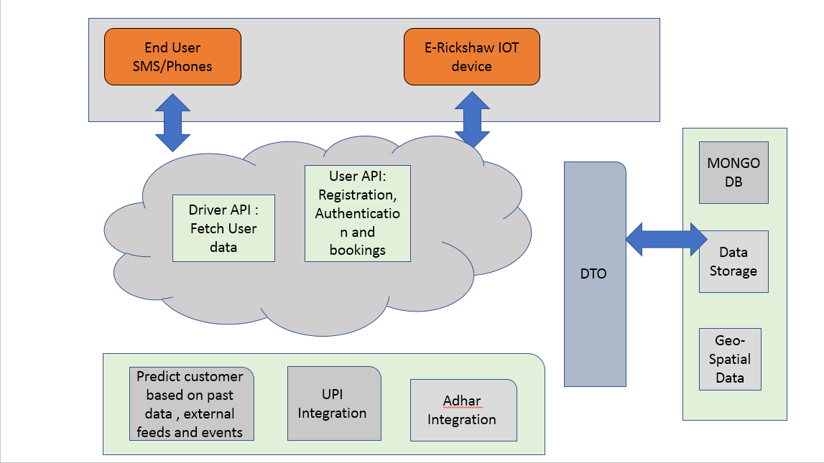

*Figure 1: Layer architecture diagram showing Last Mile connectivity system*

1. **Work Flow**

**5.1: How user is going to connect the E-rickshaw driver.**

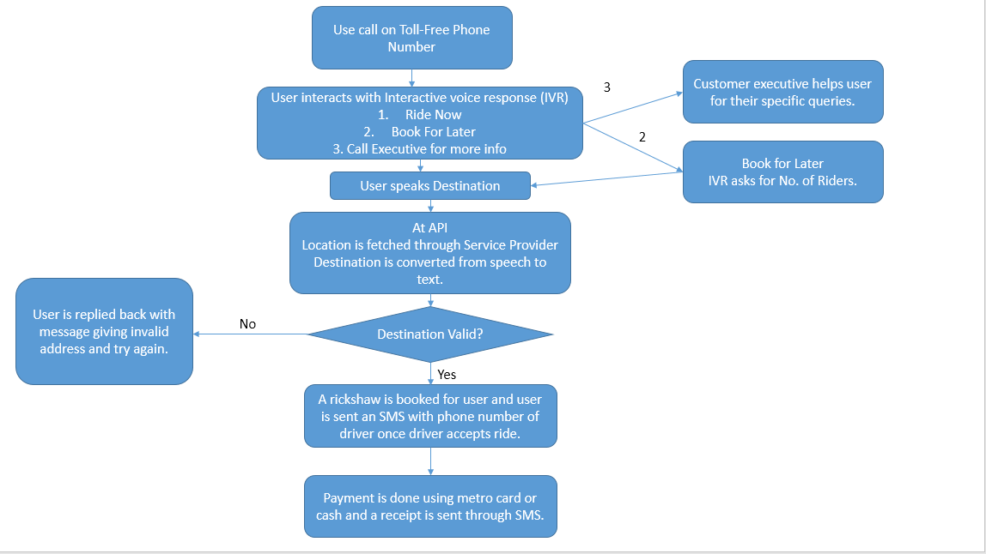

**5.2: How E-rickshaw driver is going to connect the User.**

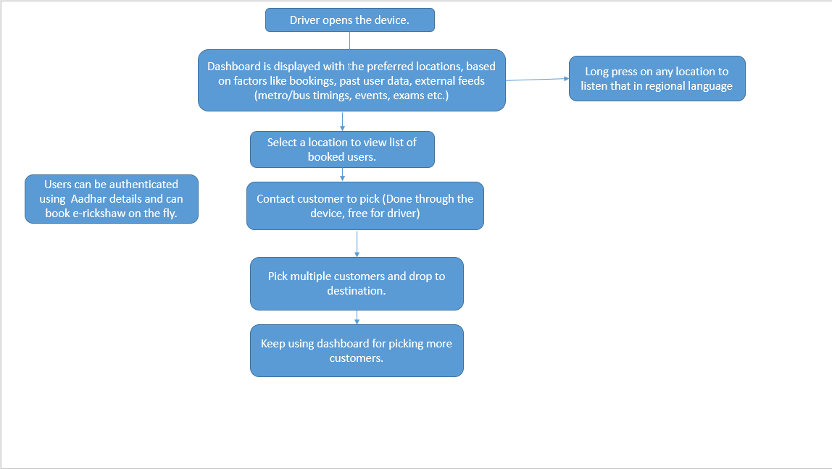

1. **Implementation**

**6.1: PhoneGap**

PhoneGap is a software development framework by Adobe System, which is used to develop mobile applications. PhoneGap has been used to produce app for all popular mobile OS platforms such as iOS, Android, BlackBerry, and Windows Mobile OS etc.

**6.2: ASP.NET Web API**

ASP.NET Web API is a framework that makes it easy to build HTTP services that reach a broad range of clients, including browsers and mobile devices. ASP.NET Web API is an ideal platform for building RESTful applications on the .NET Framework.

Page 7

**6.3: Microsoft Azure**

Windows Azure, which was later renamed as Microsoft Azure in 2014, is a cloud computing platform, designed by Microsoft to successfully build, deploy, and manage applications and services through a global network of datacenters. Azure has been used because it is easily configurable, scalable and also provides high level of security.

**6.4: UPI/Aadhar Integration**

**Aim:** To ensure payment and settlement systems in the country are safe, efficient, interoperable, authorized, accessible, inclusive and compliant with international standards.

**Vision:**

To proactively encourage electronic payment systems for ushering in a less-cash society in India.

**Authentication Service Diagram:**

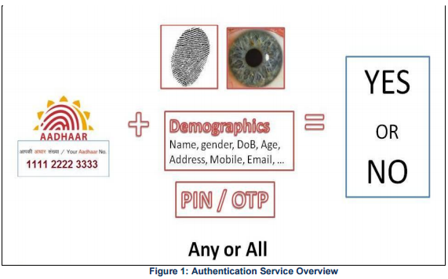

Provides their own Fingerprint API and Devices.

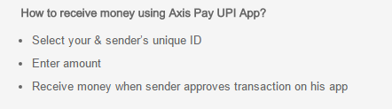

Page 8

1. **Technology Stack**

All the elements of the recommended technology are summarized in the following table:

|  |  |  |  |
| --- | --- | --- | --- |
|  | **Aspect** | **Recommendation** | |
| 1 | Web Application Development | • | Microsoft Visual Studio 2012 |
|  |  | • | Microsoft .NET 4.5 |
|  |  | • Backbone JS | |
|  |  | •   Microsoft Azure | |
|  |  | • | HTML5, jQuery, AJAX |
|  |  |  |  |
| 2 | Application Architecture Style | • | Multi-tier 2 tier architecture [Web Server + |
|  |  |  | Web API and Mongo] |
|  |  |  |  |
| 3 | Application Overall design | • | Component based, interface oriented and |
|  |  |  | object oriented |
|  |  |  |  |
| 4 | Application Presentation Layer | • | Separated Presentation using ASP.Net MVC |
| 5 | Database | • | Mongo Database |
|  |  |  |  |
| 7 | Application Hosting | • | Microsoft Azure |
|  |  |  | |

1. **Assumptions and Dependencies**
   1. An Embedded device will be integrated on E-rickshaw.
   2. Driver will have a basic training of how to use the Embedded device.
   3. All system and provider users and their respective groups/roles/permissions are pre-defined in system and will be readily available for Last Mile Connectivity by some simple API integration during later phase of development.
   4. Document will be stored on physical file location. File system details will be available at the time of development.
   5. For a non-smart phone user, geo co-ordinates will be provided by the telecom operator.

Last Mile Connectivity

1. **References**

For Aadhar Integration: <https://uidai.gov.in/images/FrontPageUpdates/aadhaar_authentication_api_1_6.pdf>

For UPI Integration: <http://www.npci.org.in/documents/Unified-Payment-Interface-API-Technology-Specifications-v11.pdf>

Twilio Voice: <https://www.twilio.com/voice-video>

Twilio Messaging: <https://www.twilio.com/messaging>

Page 10